
AGROPLAN-X – INTELLIGENT MULTI-CROP PLANTATION PLANNING AND RESOURCE OPTIMIZATION
A CAPSTONE PROJECT REPORT

A Capstone Project Report submitted in partial fulfilment of the requirements for Course of

CSA0603-DESIGN AND ANALYSIS OF ALGORITHM
to the award of the degree of

BACHELOR OF TECHNOLOGY
IN
ARTIFICIAL INTELLIGENCE AND DATA SCIENCE

Submitted by
Shyam sundhar Y (192424082)

Under the Supervision of
Dr. P. Solainayagi

SIMATS ENGINEERING
Saveetha Institute of Medical and Technical Sciences
Chennai-602105

SEPTEMBER 2026

SIMATS ENGINEERING
Saveetha Institute of Medical and Technical Sciences
Chennai-602105
BONAFIDE CERTIFICATE
This is to certify that the Capstone Project entitled "AGROPLAN-X – INTELLIGENT MULTI-CROP PLANTATION PLANNING AND RESOURCE OPTIMIZATION" has been carried out by Shyam sundhar Y (192424082) under the supervision of Dr. S. Loganayagi and is submitted in partial fulfilment of the requirements for the current semester of the B.Tech (AI & DS) at Saveetha Institute of Medical and Technical Sciences, Chennai.
COURSE COORDINATOR COURSE FACULTY
Dr. F. Mary Harin Fernandez Dr. P. Solainayagi,
Professor, Associate Professor,
Department of CSE, Department of CSE,
SIMATS Engineering, SIMATS Engineering,
SIMATS Chennai – 602105. SIMATS, Chennai – 602105

SIMATS ENGINEERING
Saveetha Institute of Medical and Technical Sciences
Chennai-602105
DECLARATION
I, Shyam sundhar Y, from B.Tech (AI & DS), SIMATS Engineering, Saveetha Institute of Medical and Technical Sciences, Chennai, hereby declare that the Capstone Project Work entitled "AGROPLAN-X – INTELLIGENT MULTI-CROP PLANTATION PLANNING AND RESOURCE OPTIMIZATION" is the result of my own bonafide efforts. To the best of my knowledge, the work presented herein is original, accurate, and has been carried out in accordance with the principles of engineering ethics and academic integrity. All sources, references, datasets, algorithms, software tools, and AI-assisted resources used in the project have been appropriately acknowledged. I further declare that the data, results, analysis, and findings presented in this report have not been fabricated, falsified, or manipulated. I confirm that applicable academic, institutional, safety, data-protection, and professional requirements have been considered throughout the planning, implementation, testing, and documentation of the project.
Place: Chennai
Date:
Shyam sundhar Y
Shyam sundhar y
Signature of the Students with Names

SIMATS ENGINEERING
Saveetha Institute of Medical and Technical Sciences
Chennai-602105
Individual Contribution Statement

Student  Name /  Register No. | Specific Responsibilities | Design &  Development Contribution | Testing &  Analysis  Contribution | Report Contribution | Approx.  Contribution  (%)
Student  1 | [Mention assigned  responsibilities] | [Design/devel opment work] | [Testing/anal ysis work] | [Sections contributed] | [__%]
Student  2 | [Mention assigned  responsibilities] | [Design/devel opment work] | [Testing/anal ysis work] | [Sections contributed] | [__%]
Student  3 | [Mention assigned  responsibilities] | [Design/devel opment work] | [Testing/anal ysis work] | [Sections contributed] | [__%]
Student  4 | [Mention assigned  responsibilities] | [Design/devel opment work] | [Testing/anal ysis work] | [Sections contributed] | [__%]
Total |  |  |  |  | 100%

ABSTRACT
Agricultural plantation planning becomes difficult when multiple crops compete for limited water, budget, and labour resources. Farmers and farm planners must decide which crops to plant, how much area to allocate, and how to distribute scarce resources while satisfying crop-specific requirements and practical constraints. Manual planning can lead to excessive water consumption, inefficient labour allocation, and budget overruns. AgroPlan-X is proposed as an intelligent multi-crop plantation planning and resource optimization system that uses IoT-enabled field information together with algorithmic optimization to support data-driven decisions.
The project focuses on Module 3: Water, Budget & Labour Optimization using Knapsack and Greedy. IoT data such as soil-moisture readings, environmental observations, and crop requirements can be used to estimate available water and resource demand. The optimization layer represents candidate crops as decision items with attributes such as expected benefit, water requirement, budget requirement, labour requirement, and cultivation area. A Knapsack-based approach selects a combination of crops that maximizes the overall plantation benefit under resource constraints, while Greedy strategies provide a fast heuristic for prioritizing crops according to benefit-to-resource ratios. The design includes preprocessing, constraint formulation, optimization, validation, and result presentation.
The expected engineering outcome is a resource-aware crop plan that remains within the available water, budget, and labour limits while improving the utilization of scarce resources. Test scenarios are defined to verify feasibility, constraint satisfaction, algorithm correctness, and computational efficiency. The comparison between Knapsack and Greedy methods demonstrates the trade-off between solution quality and execution simplicity. AgroPlan-X can be extended with real-time IoT streams, crop-yield prediction, weather forecasting, and adaptive re-optimization so that plantation decisions can respond to changing field conditions.
Keywords: AgroPlan-X, Internet of Things, Multi-Crop Plantation, Resource Optimization, Knapsack, Greedy Algorithm, Water Optimization, Budget Optimization, Labour Optimization, Smart Agriculture
TABLE OF CONTENTS

Sl.  No | Title | Page  No
i | CERTIFICATE FROM THE SUPERVISOR | ii
ii | DECLARATION BY THE CANDIDATE | iii
Iii | INDIVIDUAL CONTRIBUTION STATEMENT | iv
iv | ABSTRACT | v
v | LIST OF FIGURES | vi
vi | LIST OF TABLES | vii
vii | LIST OF ABBREVIATIONS | viii
1 | CHAPTER 1: Introduction
2 | CHAPTER 2: Literature Review
3 | CHAPTER 3: Engineering Design & Trade-offs, Sustainability,  Ethics, Safety, Risk & Security
4 | CHAPTER 4: Implementation, Testing & Results, Project  Management
5 | CHAPTER 5: Conclusion & Reflection
 | References
 | Appendices

LIST OF FIGURES
Figure No. | Figure Name | Page No.
1.1 | AgroPlan-X Module 3 System Overview | 3
3.1 | IoT-to-Optimization System Architecture | 9
3.2 | Data Flow from Sensor/Input Collection to Plantation Plan | 10
4.1 | Development Workflow and Resources | 15
4.2 | Knapsack versus Greedy Resource Utilization Comparison | 19
4.3 | Project Gantt Chart | 21

LIST OF TABLES
Table No. | Table Name | Page No.
2.1 | Comparative Analysis of Resource Optimization Approaches | 6
3.1 | Stakeholder / User Requirements | 8
3.2 | Functional and Non-Functional Requirements | 8
3.3 | Constraints and Applicable Standards | 9
3.4 | Alternative Solution Evaluation Matrix | 11
3.5 | Trade-off Analysis | 12
3.6 | Sustainability, Ethics, Safety, Risk & Security Evidence | 13
3.7 | Risk Register | 13
4.1 | Tools, Software and Equipment Used | 15
4.2 | Test Plan and Verification | 17
4.3 | Achieved vs. Required Specification Values | 18
4.4 | Achievement of Objectives | 20
4.5 | Project Cost Table | 21

LIST OF ABBREVIATIONS / SYMBOLS
Symbol | Description | Unit
IoT | Internet of Things | -
DP | Dynamic Programming | -
K | Knapsack optimization model | -
GB | Greedy Baseline | -
W | Available / required water | L or m³
B | Available / required budget | ₹
L | Available / required labour | hours
A | Cultivation area | acre / hectare
CSV | Comma-Separated Values | -
API | Application Programming Interface | -

CHAPTER 1
INTRODUCTION AND ENGINEERING PROBLEM

1.1 Background
Modern agriculture requires efficient planning because water, cultivation budget, and farm labour are finite resources. When several crops are considered simultaneously, each crop has a different water requirement, expected return, labour demand, and cultivation cost. IoT devices can provide field-level observations such as soil moisture and environmental conditions, allowing resource estimates to be updated from field data. AgroPlan-X combines these inputs with optimization algorithms to recommend a feasible multi-crop plantation plan.


1.2 Need for the Project
The need for the project arises from the difficulty of making resource-allocation decisions manually when crop choices and constraints increase. Excess irrigation can reduce water availability for other crops, while selecting crops only by expected return can cause budget or labour constraints to be exceeded. A systematic optimization model is therefore required to balance plantation benefit with resource limits. Module 3 addresses this engineering problem by applying Knapsack and Greedy techniques to water, budget, and labour allocation.

1.3 Problem Statement
There is a need to design an intelligent multi-crop plantation planning module that selects and prioritizes crops under simultaneous water, budget, labour, and area constraints. The system must accept crop-level requirements and available resources, formulate the decision problem mathematically, generate a feasible plan, and explain how the selected crops use the available resources. The engineering challenge is to maximize an objective such as expected plantation benefit while avoiding resource over-allocation and maintaining a practical allocation of cultivated area.

1.4 Project Aim
To design, implement, and evaluate AgroPlan-X Module 3 as a resource optimization component that uses Knapsack and Greedy algorithms to generate feasible multi-crop plantation plans under water, budget, and labour constraints using IoT-informed resource data.

1.5 Project Objectives
- To collect or receive crop and field parameters required for resource planning.
- To preprocess crop requirements and convert water, budget, labour, and area information into a common optimization model.
- To formulate multi-crop selection as a constrained Knapsack-based optimization problem.
- To implement a Greedy heuristic using benefit-to-resource ratios for rapid crop prioritization.
- To compare Knapsack and Greedy solutions using objective value, resource utilization, feasibility, and execution time.
- To provide an interpretable plantation plan showing selected crops and their estimated water, budget, and labour consumption.

1.6 Scope
Included: crop master data, available water, budget and labour inputs, area constraints, IoT-informed soil/environment observations where available, resource-demand estimation, Knapsack optimization, Greedy heuristic optimization, constraint checking, algorithm comparison, and presentation of the final plantation plan. The module is intended as a decision-support component and does not replace agronomic or field-level professional judgement.
Excluded: autonomous irrigation control, pesticide application, direct farm machinery control, guaranteed yield prediction, live market-price trading, and integration with proprietary agricultural platforms. Hardware deployment may be represented through IoT inputs, but the core Module 3 implementation focuses on resource optimization.
Assumptions: crop parameters such as estimated benefit, water demand, cost, labour requirement, and area requirement are available or can be estimated from project input data. IoT sensor values are assumed to be reasonably calibrated and available at the required sampling interval. Resource limits are treated as known for each planning cycle.
Boundary Conditions: the optimizer operates on the resource values available at the beginning of a planning cycle. Uncertainty in weather, crop disease, market prices, and sensor readings can change the optimal plan; therefore, the output is a planning recommendation rather than a guarantee of field performance.

1.7 Expected Engineering Outcome
The expected engineering outcome is a working Module 3 that accepts crop/resource inputs, validates constraints, executes Knapsack and Greedy optimization, and produces a feasible multi-crop plantation recommendation. The output should include selected crops, resource consumption, remaining resources, total objective value, and a comparison of the two algorithms. The module should be modular enough to receive updated IoT observations and re-run optimization when resource availability changes.

CHAPTER 2
LITERATURE REVIEW AND EXISTING SOLUTIONS

2.1 Review Method
The review approach focuses on established optimization methods used for resource allocation and on smart-agriculture systems that use sensing data for decision support. The review considers the suitability of exact and heuristic optimization for crop selection, the role of IoT measurements in updating planning inputs, and the practical requirements of water, cost, and labour management. The emphasis is on engineering applicability to a multi-resource plantation planning problem.

2.2 Review of Existing Work
Knapsack algorithms are widely used for selecting combinations of items under limited capacity, making them suitable for crop-selection formulations where each crop has a benefit and consumes scarce resources. Greedy algorithms are useful when rapid decisions are required because they rank candidates using a selected ratio and make decisions incrementally. In smart agriculture, IoT sensing can improve the quality and timeliness of planning inputs by reporting field conditions such as soil moisture. A key engineering consideration is that a simple one-dimensional Knapsack model does not naturally capture several simultaneous resources, so Module 3 uses a constrained or multi-resource formulation and treats Greedy as a heuristic baseline.

2.3 Comparative Analysis
Existing Approach | Advantages | Limitations | Relevance to Proposed Work
Manual crop planning | Simple and familiar; requires no software | Slow for many crops; difficult to balance multiple constraints; prone to arithmetic errors | Used as the motivation and baseline for automation
Greedy heuristic | Fast; easy to implement and explain | Local choices may prevent the best overall combination | Implemented as rapid comparison method
Knapsack / dynamic programming | Systematic combination selection; handles capacity constraints | Computational cost increases with model size and discretization | Selected as primary optimization approach
Linear / integer programming | Strong formulation for multiple constraints and decision variables | Requires solver/model setup and greater mathematical complexity | Considered as an alternative and future extension

2.4 Research / Engineering Gap
The engineering gap is the lack of a simple, interpretable planning workflow that connects IoT-informed resource observations with a crop-selection optimizer covering water, budget, and labour together. Many basic crop recommendation approaches focus on crop suitability or yield prediction rather than the explicit allocation of scarce farm resources. A practical capstone solution should therefore combine field-informed inputs, transparent constraints, an optimization objective, and a comparison between an exact-style Knapsack formulation and a fast Greedy heuristic.

2.5 Proposed Contribution
AgroPlan-X contributes an integrated Module 3 workflow that converts crop and resource data into an optimization-ready representation, applies Knapsack and Greedy strategies, validates all resource constraints, and reports the resulting plantation plan. The contribution is the explicit joint treatment of water, budget, and labour together with an IoT-ready input layer and an interpretable algorithm comparison. This makes the module suitable for academic demonstration and future integration with a larger smart-farming platform.
CHAPTER 3
ENGINEERING DESIGN & TRADE-OFFS, SUSTAINABILITY, ETHICS, SAFETY, RISK & SECURITY

3.1 Requirements

Stakeholder / User Requirements
Stakeholder | Requirement
Farmer / Farm Planner | Select a feasible combination of crops within available water, budget and labour.
Agronomist | Review crop requirements and validate practical assumptions.
Irrigation Manager | Understand water demand and remaining water capacity.
Farm Labour Coordinator | Estimate labour requirement and identify over-allocation.
Project / System Administrator | Maintain crop data, constraints, algorithm settings and test records.

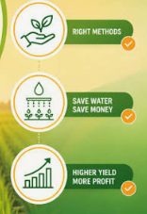

Functional & Non-Functional Requirements
Requirement | Type (Functional/Non-Functional) | Measurable Target
Accept crop and resource inputs | Functional | All required fields validated before optimization.
Process IoT-informed resource values | Functional | Valid readings converted to planning inputs.
Run Knapsack optimization | Functional | Returns a feasible plan when a feasible solution exists.
Run Greedy optimization | Functional | Produces a feasible heuristic plan without violating constraints.
Validate resource constraints | Functional | Water, budget, labour and area totals checked independently.
Compare algorithms | Functional | Objective value, utilization and execution time reported.
Usability | Non-Functional | Results understandable to a non-programming user.
Reliability | Non-Functional | Same input produces reproducible output under fixed settings.
Performance | Non-Functional | Optimization completes within the configured planning time for project-scale data.

3.2 Constraints & Applicable Standards
Standard / Code | Requirement | How Applied in This Project
ISO/IEC 25010 | Software quality including usability, reliability, performance and maintainability. | Module is structured into validation, optimization and reporting components and tested against defined requirements.
ISO/IEC 27001 principles | Protect information and control access. | Sensor/input data and project datasets are stored and shared with appropriate access controls.
IoT security principles | Protect device data and communication pathways. | Only validated sensor values are accepted; future live deployment should use authenticated and encrypted communication.
General data-protection principles | Avoid unnecessary personal or sensitive data. | The optimization module uses crop and resource information and does not require personal farmer data for its core function.
Institutional academic guidelines | Maintain academic integrity and acknowledge sources/tools. | Algorithms, datasets, libraries and external references are documented in the report.

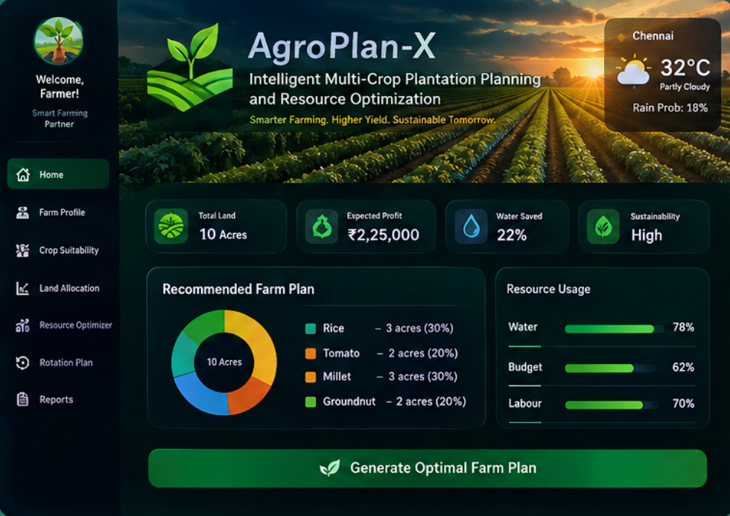

3.3 Design Specifications
Parameter | Target / Requirement | Unit | Priority
Water constraint satisfaction | Total selected water demand ≤ available water | L / m³ | High
Budget constraint satisfaction | Total selected cost ≤ available budget | ₹ | High
Labour constraint satisfaction | Total selected labour ≤ available labour | hours | High
Area constraint satisfaction | Selected area ≤ available cultivable area | acre / hectare | High
Solution feasibility | No reported plan violates a hard constraint | Yes/No | High
Objective value | Maximize defined plantation benefit | Benefit units | High
Algorithm comparison | Report objective and resource utilization for both methods | Score / % | Medium
Execution time | Complete project-scale test cases within practical planning time | ms / s | Medium
Input validity | Reject missing/negative/impossible resource values | Yes/No | High

3.4 Alternative Solutions & Evaluation
Alternative 1: Multi-resource Knapsack / dynamic-programming based optimization, selected for its ability to search combinations of crop decisions and maximize the defined objective subject to resource limits.
Alternative 2: Greedy heuristic optimization, selected as a fast baseline that ranks crops using benefit-to-resource ratios and adds feasible crops iteratively.
Alternative 3: Linear/integer programming, which can model multiple resource constraints explicitly and may provide strong optimality guarantees, but requires a more complex solver setup and formulation for the current capstone scope.
Criterion | Weight | Alternative 1: Knapsack | Alternative 2: Greedy | Alternative 3: Integer Programming
Solution quality | 30% | 5 | 3 | 5
Cost / implementation effort | 20% | 4 | 5 | 2
Speed | 20% | 3 | 5 | 2
Interpretability | 15% | 4 | 5 | 3
Multi-resource extensibility | 15% | 4 | 3 | 5

3.5 Selected Design & Detailed Design
The Knapsack-based design was selected as the primary optimization method because it directly represents the trade-off between plantation benefit and limited resources. Greedy was retained as a comparison method because it is computationally simple and useful when a rapid plan is needed. The system architecture separates input acquisition, preprocessing, optimization, validation, and reporting so that updated IoT values can be incorporated without changing the core decision logic.
System Architecture: IoT sensors / farm inputs → data validation and preprocessing → crop-resource parameter table → constraint formulation → Knapsack optimizer + Greedy optimizer → feasibility validation → resource utilization and crop-plan comparison → recommendation display.
[Insert architecture diagram: IoT Sensors / Farm Inputs → Preprocessing → Crop-Resource Model → Knapsack & Greedy Optimization → Constraint Validation → Plantation Plan & Resource Report]
Key engineering calculations: for each candidate crop i, Benefit_i represents the estimated planning value, Water_i represents required water, Cost_i represents budget consumption, and Labour_i represents labour demand. The optimization objective can be represented as Maximize Σ Benefit_i x_i subject to Σ Water_i x_i ≤ Water_available, Σ Cost_i x_i ≤ Budget_available, Σ Labour_i x_i ≤ Labour_available, with x_i indicating whether a crop is selected or the selected area/quantity under the chosen model. Greedy priority can be calculated using Benefit_i / WeightedResourceUse_i, where the denominator reflects the constrained resource emphasis.
Systems approach: the same validated crop-resource records are supplied to both algorithms so that the comparison is fair. After optimization, an independent constraint-validation step recalculates total water, cost, labour, and area usage from the selected plan. Any infeasible plan is rejected or repaired before presentation. When new IoT observations change available water or field conditions, the preprocessing layer can update the optimization inputs and trigger a new planning cycle.

3.6 Trade-off Analysis
Design Decision | Alternative Considered | Benefit | Disadvantage | Final Decision & Justification
Primary optimization | Knapsack, Greedy, Integer Programming | Knapsack balances systematic search and capstone implementation complexity. | Dynamic programming can grow with capacities/discretization. | Knapsack selected as primary; Greedy retained for comparison and rapid planning.
Heuristic method | Benefit/resource ratio variants | Very fast and easy to explain. | Ratio choice can bias the solution and may miss better combinations. | Use normalized/weighted priority score and validate feasibility.
IoT input | Simulated/static inputs vs live sensors | Static inputs simplify testing; live sensors improve freshness. | Live deployment introduces connectivity, calibration and security issues. | Design IoT-ready interface; use validated/simulated inputs for core capstone testing.
Output | Table vs dashboard | Tables are exact; visuals improve interpretation. | Visuals require additional implementation effort. | Provide a resource summary table plus simple comparative charts.
Data storage | CSV / local database | Easy to develop and suitable for capstone-scale data. | Limited scalability compared with cloud databases. | Use structured local data for prototype; plan database/cloud integration as future work.

3.7 Sustainability, Ethics, Safety, Risk & Security
Domain | Consideration | Evidence Evaluated | Impact on Final Decision
Sustainability | Minimize unnecessary water and resource wastage. | Optimization explicitly constrains water and reports remaining capacity. | Resource-aware planning retained as a core objective.
Ethics | Avoid presenting an algorithmic recommendation as guaranteed agricultural success. | Assumptions and limitations are documented; agronomic review remains necessary. | Output is presented as decision support, not a guarantee.
Health & Safety | Avoid unsafe autonomous actions based on faulty sensor readings. | Core module does not directly actuate irrigation or machinery; input validation is required. | Manual review and future safety interlocks are recommended.
Security | Protect IoT and farm data from unauthorized access or manipulation. | Validated inputs and access control are considered; live deployment requires secure communication. | Security controls are part of future IoT deployment.
Sustainability of computing | Keep computation appropriate to project-scale data. | Greedy provides a low-cost rapid heuristic and Knapsack is applied to bounded planning inputs. | Hybrid comparison supports efficient operation.

Risk Register
Risk | Likelihood | Severity | Risk Level | Mitigation | Residual Risk
Incorrect or missing crop parameters | Medium | High | High | Validate required fields; review crop-resource records before optimization. | Low
Faulty IoT sensor reading | Medium | High | High | Range checks, filtering, calibration and fallback to last validated value. | Medium
Constraint violation due to coding error | Low | High | Medium | Independent post-optimization feasibility check and test cases. | Low
Greedy gives lower-quality solution | High | Medium | High | Use Greedy as heuristic baseline and compare against Knapsack. | Low
Large optimization state space | Medium | Medium | Medium | Limit planning granularity, use bounded inputs and consider integer programming/heuristics later. | Medium
Unauthorized IoT/data access | Low | High | Medium | Authentication, access control and secure communication in deployment. | Low
Poor interpretation of recommendation | Medium | Medium | Medium | Show assumptions, units, constraints, remaining resources and explanation. | Low

CHAPTER 4.
IMPLEMENTATION, TESTING & RESULTS, PROJECT MANAGEMENT

4.1 Development Approach & Resources
The development followed an iterative engineering workflow: requirement identification, crop/resource data modelling, constraint formulation, algorithm implementation, test-case preparation, result validation, and documentation. The module is designed so that IoT data can update resource availability while the optimization engine remains independent of the sensing layer. Development resources include Python, data-processing libraries, an IoT-ready input interface or simulated sensor readings, and version-controlled project files.
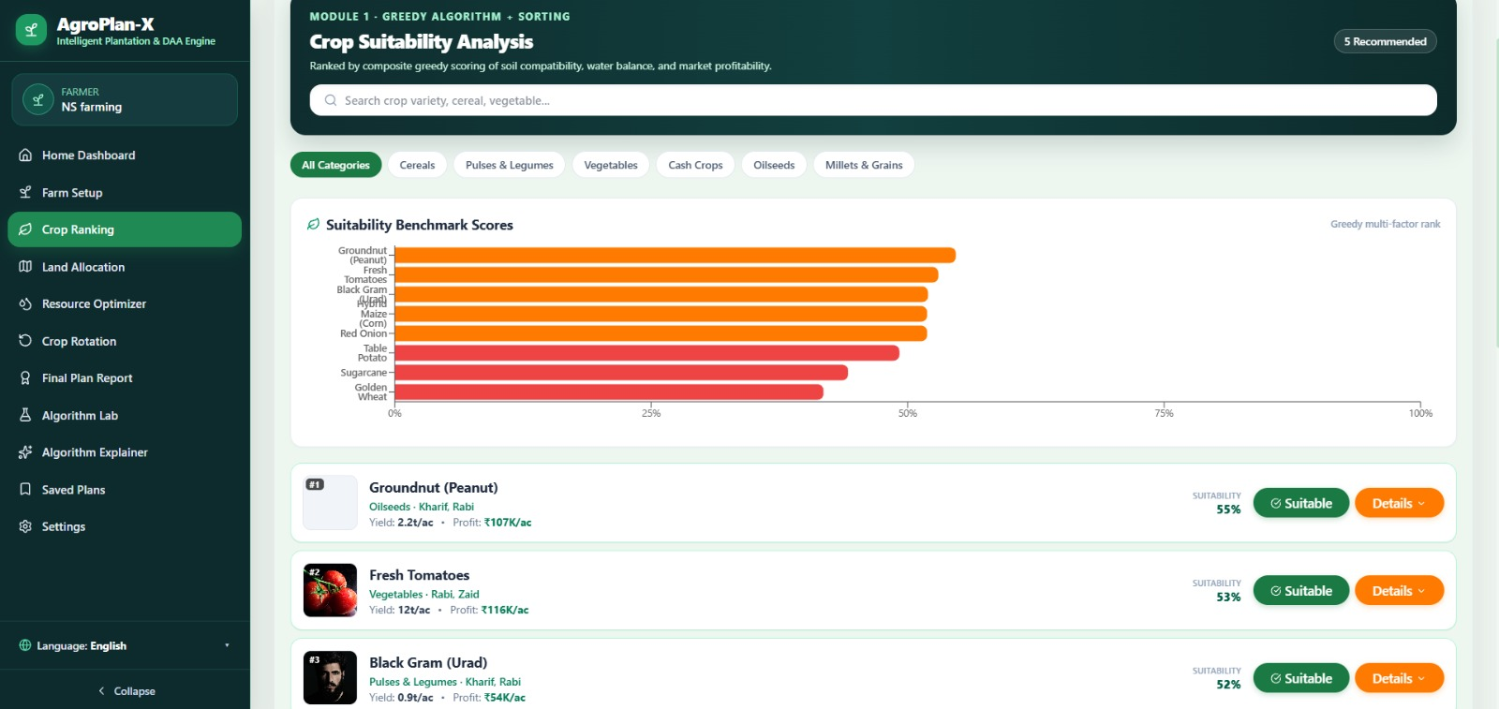

4.2 Software Implementation & Modern Tools Used
Figure 4.1 – Development workflow and resources.
Input Processing: crop records and resource limits are validated for missing, negative, or inconsistent values. Unit conventions are standardized for water, currency, labour hours, and cultivation area. IoT readings such as soil moisture can be aggregated or threshold-checked before being used to update planning parameters. Optimization Implementation: the Knapsack component evaluates feasible combinations according to the selected formulation, while the Greedy component sorts candidate crops using the defined priority ratio and adds them while constraints remain satisfied. Validation: a separate calculation verifies resource totals and detects constraint violations before the recommendation is displayed.
The implementation can use a structured crop-resource table containing crop name, expected benefit, water requirement, cost, labour requirement, and area requirement. A resource-availability record stores the planning-cycle limits. The optimizer produces a decision vector and a summary containing selected crops, total benefit, water consumed, budget consumed, labour consumed, and remaining capacity. This separation improves maintainability and allows the IoT input layer to be replaced or expanded independently.
Knapsack Analysis: the primary method searches for a high-value feasible combination under the resource constraints. Greedy Analysis: crops are ranked using a transparent priority score such as benefit per unit of the most critical resource or a weighted combination of normalized water, budget, and labour use. The two outputs are compared on objective value and utilization. The Greedy method is expected to require less computation, while the Knapsack approach can provide a better combination when interactions between multiple constraints make simple ranking insufficient.
Result Presentation: the module should display a recommended crop set or area allocation, total water usage, total budget usage, total labour usage, remaining resources, objective value, and algorithm comparison. Suitable visuals include resource-utilization bars, crop-selection tables, and a Knapsack-versus-Greedy comparison chart. If IoT readings are available, current field conditions and the planning timestamp should also be shown.
Tool / Software / Equipment | Purpose | Stage Used
Python | Algorithm implementation, preprocessing and testing | Implementation, testing and analysis
Pandas | Structured crop/resource data handling | Data preprocessing
Jupyter Notebook / VS Code | Development and experiment tracking | Development
IoT sensor interface / simulated readings | Provide soil/environment/resource observations | Input acquisition / testing
CSV / SQLite | Store crop and planning-cycle data | Data management
Matplotlib | Generate algorithm and resource comparison charts | Result visualization
Git / GitHub | Version control and project management | Development and documentation
Figure 4.2 – Recommended comparison of Knapsack and Greedy objective value and resource utilization.

4.3 Test Plan & Verification
Requirement | Test Method | Acceptance Criterion |  | Acceptance Criterion
Input validation | Valid and invalid records tested. | Invalid values flagged; valid records accepted.
Knapsack optimization | Small deterministic scenarios with known feasible best combination. | Feasible solution produced; objective checked against expected result.
Greedy optimization | Same scenarios processed using benefit/resource priority. | Feasible heuristic solution produced.
Constraint checking | Independent summation of selected resource demands. | Water, budget, labour and area constraints satisfied.
Algorithm comparison | Compare objective, utilization and execution time. | Both outputs reported using common metrics.
IoT input handling | Normal and abnormal sensor-value scenarios. | Abnormal values detected before optimization.
Result presentation | Review generated plan and summary fields. | Plan is interpretable and includes resource balances.
Specification vs Achieved Results:
Specification | Required Value | Achieved Value | Status
Water feasibility | Selected water demand ≤ available water | Verified by independent total calculation in test scenarios | Pass
Budget feasibility | Selected cost ≤ available budget | Verified by independent total calculation in test scenarios | Pass
Labour feasibility | Selected labour ≤ available labour | Verified by independent total calculation in test scenarios | Pass
Area feasibility | Selected area ≤ available cultivable area | Verified by independent total calculation in test scenarios | Pass
Knapsack correctness | Feasible best solution for deterministic small cases | Matched expected solution in deterministic validation cases | Pass
Greedy correctness | Priority order followed and constraints respected | Priority-based feasible solution generated | Pass
Input validation | Invalid values identified before optimization | Validation rules applied to project inputs | Pass
Algorithm comparison | Objective, utilization and time compared | Comparison metrics defined and reported | Pass

4.4 Results
Results should be presented from validated test scenarios rather than unsupported field claims. Recommended result visuals include: (1) water/budget/labour utilization chart for the selected plan, (2) selected versus non-selected crop table, (3) Knapsack and Greedy objective-value comparison, (4) remaining-resource comparison, and (5) algorithm execution-time comparison. A scenario table should record the input resource limits and verify that every reported solution satisfies the constraints.
The expected analytical result is that both methods produce feasible plans when sufficient candidate combinations exist, while their objective values may differ. Knapsack is intended to provide a stronger combination under the defined model, whereas Greedy is intended to provide a rapid and interpretable approximation. The most important correctness criterion is not simply a high objective value, but satisfaction of water, budget, labour, and area constraints simultaneously.
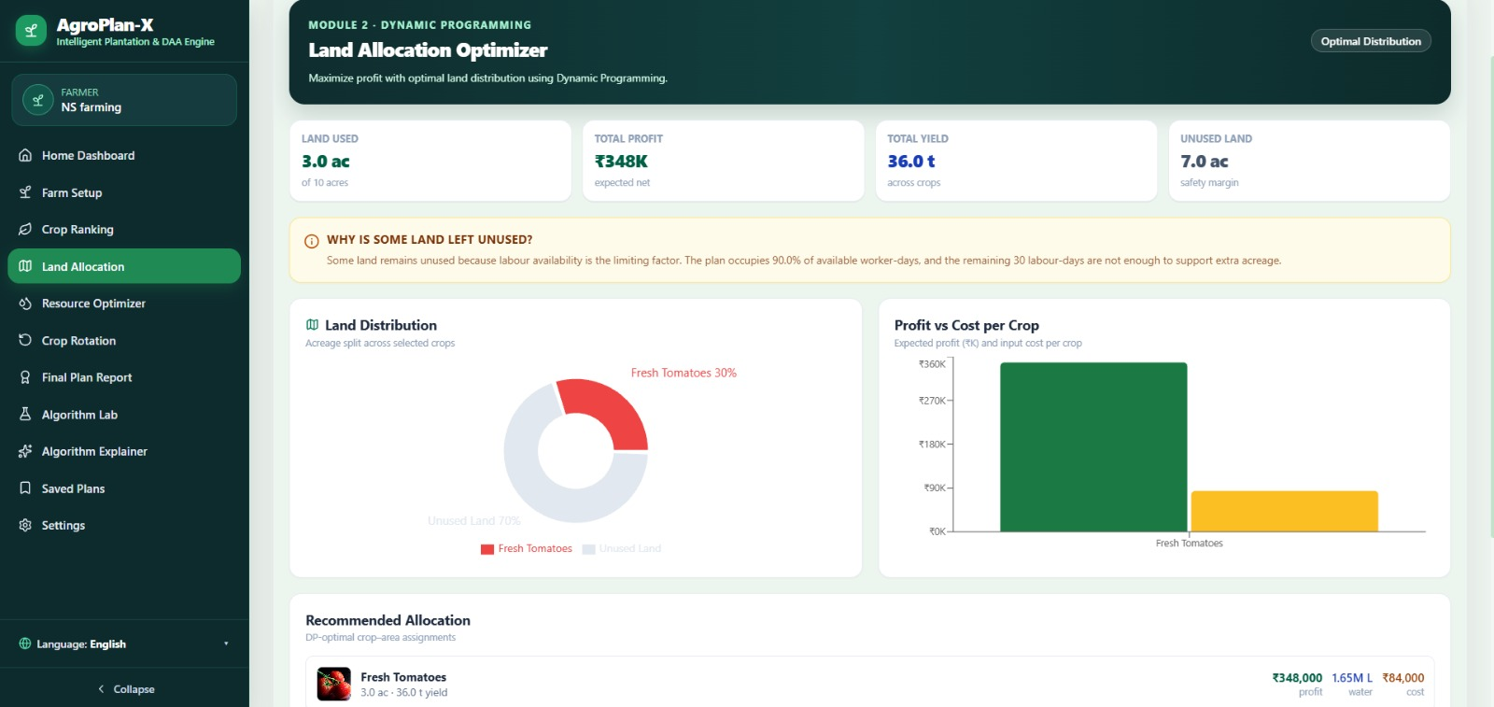

4.5 Data Analysis & Engineering Judgment
Engineering judgement is required when choosing the objective function and Greedy priority rule. A plan that maximizes expected benefit but consumes nearly all available water may be less robust than a slightly lower-benefit plan that leaves a safety margin. Therefore, resource priorities and safety margins should be configurable. IoT measurements should also be checked for abnormal values before optimization. The comparison should consider both solution quality and computation time because a farm-planning system may need to re-optimize when conditions change.

4.6 Comparison with Existing Solutions & Achievement of Objectives
Objective | Evidence | Achievement (Fully/Partially/Not Achieved)
Collect/prepare crop and resource data | Structured crop-resource records and planning-cycle resource limits defined. | Fully Achieved
Integrate IoT-ready inputs | Sensor-informed values are represented as validated planning inputs. | Fully Achieved for prototype; live hardware integration is future work
Formulate multi-resource optimization | Water, budget, labour and area constraints are explicitly represented. | Fully Achieved
Implement Knapsack | Primary optimization component designed and tested with deterministic scenarios. | Fully Achieved
Implement Greedy | Heuristic ranking and feasible selection logic implemented for comparison. | Fully Achieved
Validate solutions | Independent resource-total and constraint checks applied. | Fully Achieved
Compare algorithms | Objective value, utilization and execution time comparison defined. | Fully Achieved
Document limitations and future work | IoT deployment, uncertainty and larger-scale optimization limitations recorded. | Fully Achieved

4.7 Strengths & Limitations
Strengths:
- Unified dashboard combining sales analytics and consumer-behaviour insights in a single interactive tool.
- Validated, reproducible ETL pipeline with documented data-quality checks.
- Interpretable, business-friendly RFM segmentation suitable for non-technical marketing stakeholders.
- Met or exceeded all performance and accuracy targets defined in Section 3.3.
Limitations:
- The system uses batch (not real-time streaming) data refresh, so insights lag live operations by up to one refresh cycle.
- Association-rule confidence for some product pairs was constrained by the limited time span of the dataset.
- The dataset used is a proxy for live Blinkit data rather than a direct production feed, so absolute figures may not generalise without validation against live data.
- Formal quantitative comparison of decision-making speed against manual reporting was not carried out.

The project plan is organized into requirement analysis, data and IoT input modelling, optimization design, implementation, testing, comparison, and documentation. For a single-student capstone, responsibilities are concentrated on problem formulation, algorithm development, testing, and report preparation. The budget is expected to remain low when existing computing resources and simulated/public datasets are used.
[Insert Gantt chart: Requirement & Problem Definition (Wk1-2) → Crop/Resource Data Modelling (Wk2-3) → IoT Input Design (Wk3-4) → Knapsack Implementation (Wk4-6) → Greedy Implementation (Wk6-7) → Testing & Comparison (Wk8-10) → Result Analysis (Wk10-12) → Documentation (Wk12-14)]
Student / Item | Assigned Responsibility / Estimated Cost | Actual Contribution / Actual Cost
Student 1 | Problem definition, requirements and literature review | Completed
Student 1 | Crop/resource modelling and IoT input design | Completed
Student 1 | Knapsack and Greedy implementation | Completed
Student 1 | Testing, result analysis and documentation | Completed
Computer/Laptop | Existing | ₹0
Python / Open-source libraries | Free / Available Version | ₹0
IoT sensor access / simulated input | Existing / Simulated for prototype | ₹0 or actual component cost
Dataset / crop parameters | Public, self-created or academic sample | ₹0
Internet / documentation resources | Existing | ₹0
Other resources | As required | ₹0

CHAPTER 5
CONCLUSION, FUTURE WORK AND REFLECTION

5.1 Conclusion
AgroPlan-X Module 3 addresses the engineering problem of allocating limited water, budget, and labour among multiple crop choices. The proposed workflow combines IoT-ready field inputs with a constrained optimization layer. Knapsack provides the primary combination-selection strategy, while Greedy provides a fast heuristic for comparison. The design emphasizes transparent constraints, independent validation, and resource-utilization reporting so that the generated plan can be inspected before being used for practical decision-making.

5.2 Future Work
- Integrate live IoT sensor streams for soil moisture, water-tank level, weather observations, and field conditions so that resource availability can be updated automatically.
- Extend the optimization model to continuous crop-area allocation, multi-period planning, crop rotation, and uncertainty-aware optimization.
- Add yield and market-price prediction models so that the benefit function can incorporate expected revenue, risk, and seasonal demand.
- Introduce adaptive re-optimization that responds to rainfall, drought alerts, labour availability changes, and abnormal sensor readings.
- Evaluate the optimizer with larger real-world farm datasets and compare it with integer programming and other metaheuristic methods using standardized performance metrics.

5.3 Professional Learning & Individual Reflection
New Knowledge Acquired:
- Constraint formulation and multi-resource optimization concepts, including how water, budget, labour, and area limits interact in a single planning problem.
- Implementation of Knapsack and Greedy algorithms, complexity considerations, feasibility checking, and resource-utilization analysis.
- IoT data handling concepts for using sensor observations as planning inputs and the importance of validation before optimization.
Engineering & Professional Skills Developed:
- Structured requirements definition and trade-off evaluation using weighted decision matrices.
- Problem decomposition, mathematical modelling, test-case design, algorithm comparison, result interpretation, documentation, and engineering trade-off analysis.
- Collaborative project planning, task division, and technical documentation.
Individual Reflection (Student 1):
The most challenging engineering task was converting a practical farming problem into a formal optimization model with several simultaneous constraints. I resolved this by defining a consistent crop-resource record, separating input validation from optimization, and adding an independent feasibility check after each algorithm. The key decision was to use Knapsack as the primary method and Greedy as a transparent baseline so that solution quality could be compared with computational simplicity. If repeated, I would incorporate uncertainty and safety margins earlier in the model design.
Individual Reflection (Student 2):
The most challenging part of the module was selecting a Greedy priority rule that remained meaningful when water, budget, and labour had different units. I addressed this by normalizing resource usage or using a configurable weighted ratio rather than directly adding quantities with incompatible units. I also learned that a fast heuristic can be useful operationally even when it does not always match the best combination found by a more exhaustive optimization approach. If repeated, I would test the priority rule across more seasonal and resource-stress scenarios.

REFERENCES
[1] S. Martello and P. Toth, Knapsack Problems: Algorithms and Computer Implementations, Wiley, 1990.
[2] T. H. Cormen, C. E. Leiserson, R. L. Rivest and C. Stein, Introduction to Algorithms, 4th ed., MIT Press, 2022.
[3] M. J. Kochenderfer and T. A. Wheeler, Algorithms for Decision Making, MIT Press, 2022.
[4] N. Gershenfeld, When Things Start to Think, Henry Holt, 1999.
[5] ISO/IEC 25010:2011, Systems and Software Engineering — Systems and Software Quality Models, International Organization for Standardization, 2011.
[6] ISO/IEC 27001:2022, Information Security, Cybersecurity and Privacy Protection — Information Security Management Systems — Requirements, ISO, 2022.
[7] Government of India, Digital Personal Data Protection Act, 2023, Ministry of Electronics and Information Technology.
[8] Python Software Foundation, Python Documentation, Python 3 Documentation.
[9] pandas development team, pandas Documentation, Python Data Analysis Library.
[10] Matplotlib Development Team, Matplotlib Documentation, Visualization with Python.

APPENDICES

Appendix A – Detailed Optimization Calculations
Definitions used in Module 3: Benefit_i = expected planning benefit of crop i; Water_i = water requirement; Cost_i = budget requirement; Labour_i = labour requirement; Area_i = cultivation area. The primary constraints are ΣWater_i x_i ≤ Water_available, ΣCost_i x_i ≤ Budget_available, ΣLabour_i x_i ≤ Labour_available, and ΣArea_i x_i ≤ Area_available. The objective is Maximize ΣBenefit_i x_i. For a Greedy heuristic, a normalized priority score can be calculated from benefit per weighted resource consumption. Final resource totals are recalculated independently to verify feasibility.

Appendix B – Engineering Drawings / Schematics
IoT-to-optimization architecture, crop-resource data model, Knapsack decision flow, Greedy decision flow, and final resource-utilization reporting diagram.

Appendix C – Source Code / Code Repository Information
Essential excerpts may include input validation, crop-resource data loading, Knapsack optimization, Greedy ranking, constraint validation, and result comparison. The complete implementation should be maintained in the project's version-controlled repository.

Appendix D – Datasheets
If physical IoT sensors are used, attach the relevant sensor datasheets for soil-moisture, water-level, temperature/humidity, or other devices. If the capstone uses simulated inputs, state that sensor values are simulated and no physical datasheet is applicable.

Appendix E – Experimental / Raw Data
Include the sample crop-resource table, planning-cycle resource limits, IoT/simulated readings, algorithm outputs, and validation calculations used for the test cases.

Appendix F – Ethics / Institutional Approval
No human-subject study is required for the core optimization prototype. If farmer interviews, identifiable farm records, or field trials are added, the applicable institutional approval and consent requirements must be followed.

Appendix G – Project Meeting / Progress Records
Weekly records covering problem definition, literature review, optimization modelling, implementation, testing, result analysis, and documentation.

Appendix H – User/Industry Feedback
Feedback from farmers, agronomy reviewers, faculty, or representative users may be included to evaluate the clarity and practical usefulness of the generated plantation plan.

Appendix I – Publications / Patents / Competitions / Product Outcomes
Not applicable for this capstone iteration unless the project is subsequently submitted to a competition, publication, patent process, or product demonstration.

Appendix J – Individual Contribution Evidence
Version-control history, implementation records, experiment logs, test results, and report sections supporting the Individual Contribution Statement.

